# Aurora

[NextWork.org](https://community.nextwork.org/c/i-have-a-question?automatic_login=true)

# Database with EC2 Instance

Prajit Venkatachalam

<https://www.linkedin.com/in/prajit-venkatachalam/>

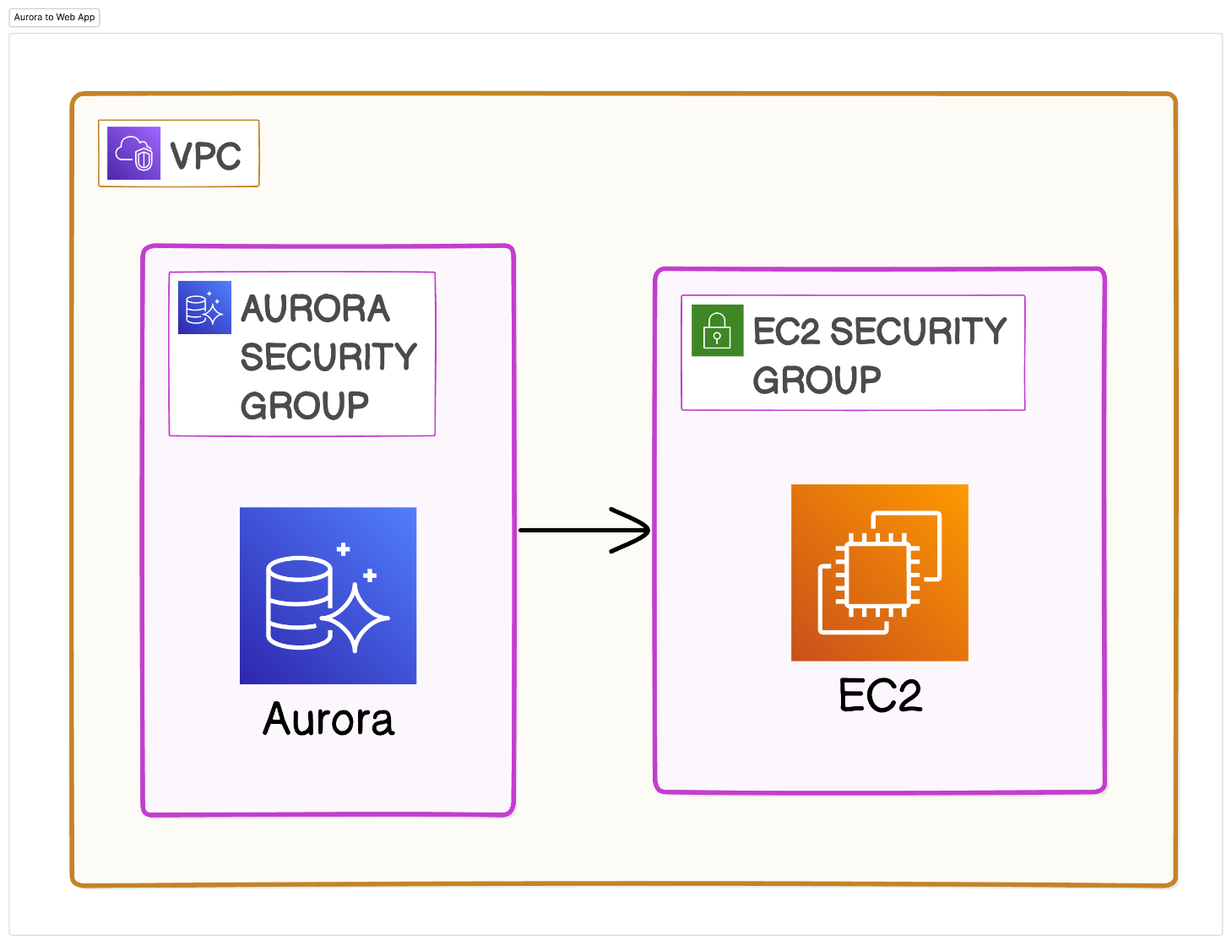



## Introducing Today's Project!

### What is Amazon Aurora?

### Amazon Aurora is a relational database service on AWS designed for handling large-scale databases that demand high performance and reliability. It's ideal for applications where uptime and speed are critical.

### How I used Amazon Aurora in this project

In this project, I deployed an Amazon Aurora database, configured an EC2 instance independently, and linked the Aurora database to the EC2 instance, which served as a web server.

### One thing I didn't expect in this project was...

One unexpected aspect of this project was that I had to set up my EC2 instance first before I could complete the configuration of my Amazon Aurora database.

### This project took me…

### This project took me 1.5 hours to complete include report writing.



## In the first part of my project...

### Creating an Aurora Cluster

A relational database organizes data into tables with rows and columns, similar to a spreadsheet. It's called "relational" because the rows correspond to specific columns, and the columns describe data in the rows.

Aurora is an ideal choice for large-scale relational databases that demand high performance and minimal downtime, offering enhanced speed, availability, and scalability compared to standard database solutions.

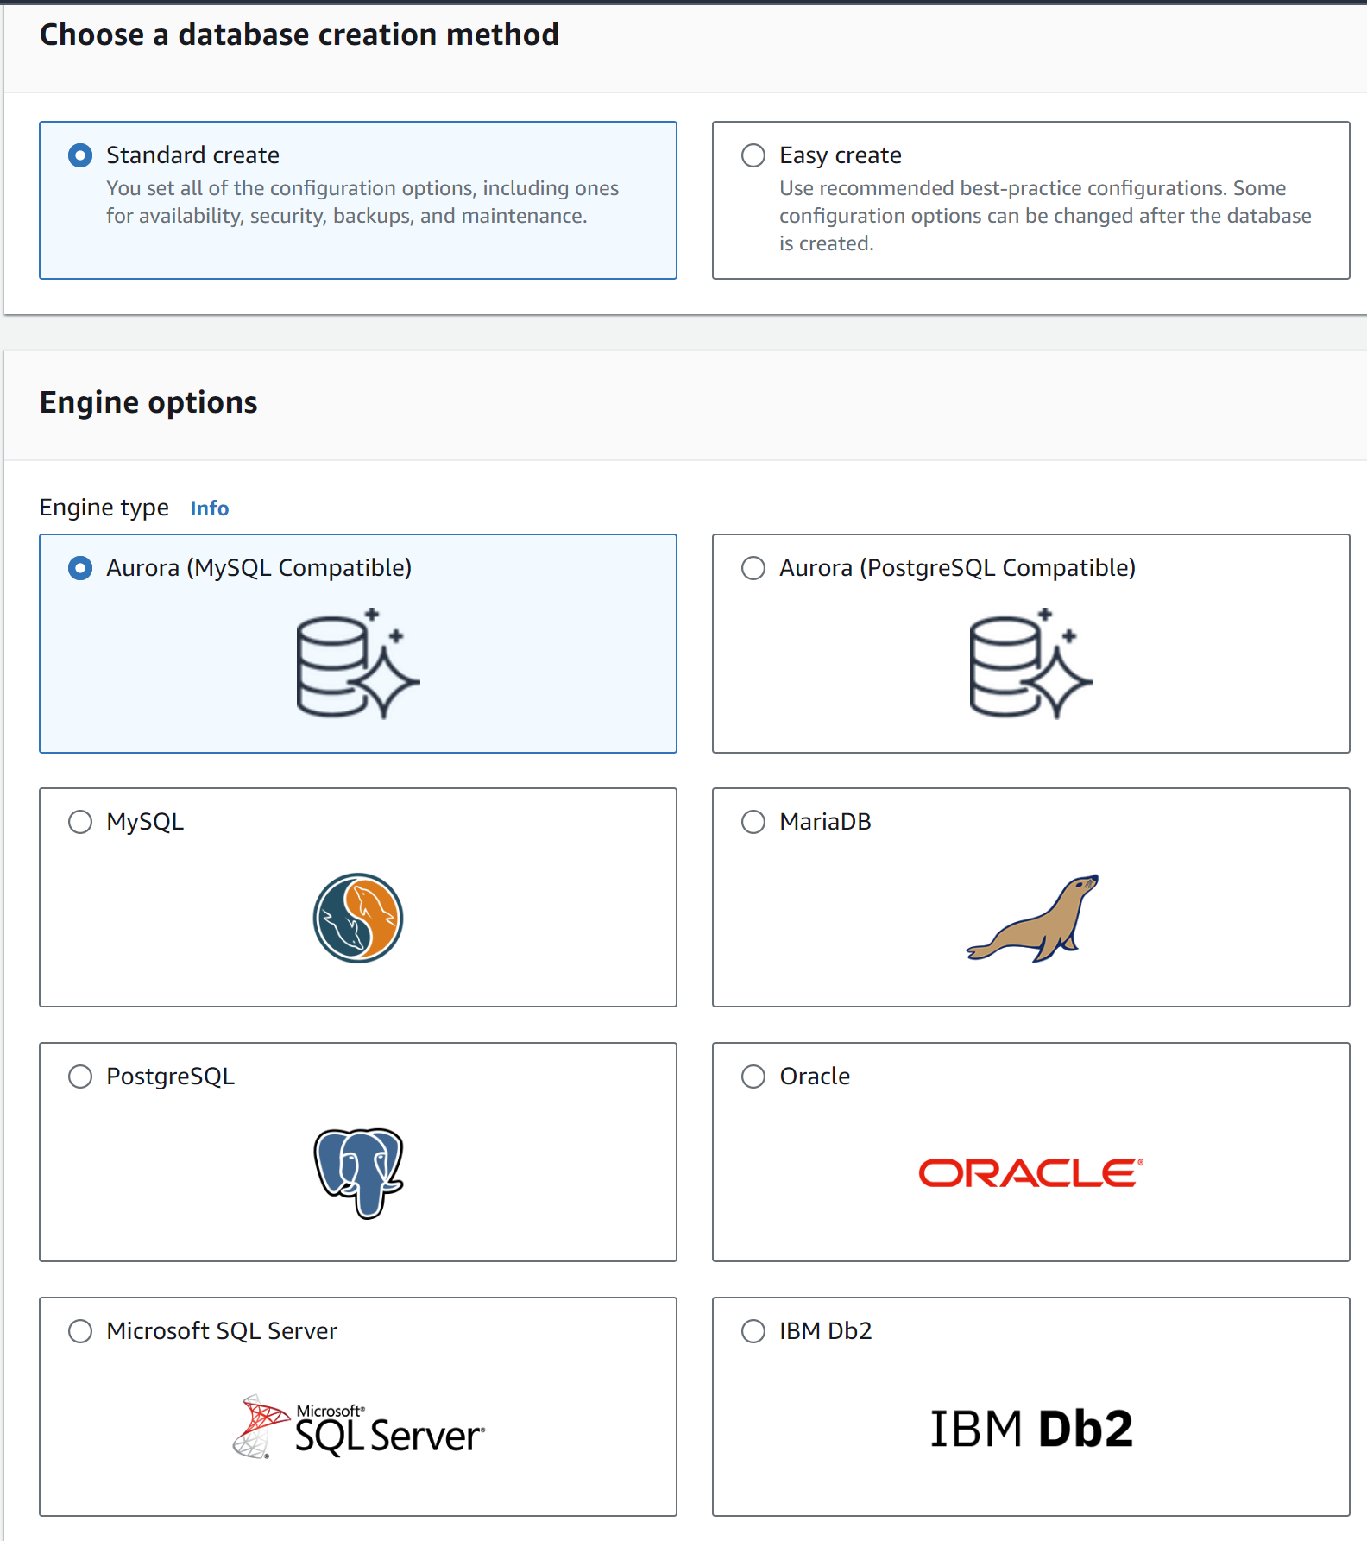



## Halfway through I stopped!

I paused the creation of my Aurora database because I need to connect it to an EC2 instance first before completing the database setup, so I had to launch an EC2 instance first.

### Features of my EC2 instance

I created a new key pair for my EC2 instance to enhance its security and provide direct access. This will allow me to configure the instance, develop a web app, and connect it to the Aurora database.

When I created my EC2 instance, I paid close attention to the instance's public IPv4 DNS and the key pair name. These two elements work together to indicate the location of the EC2 instance (my web server) and the keys that will provide access to it.

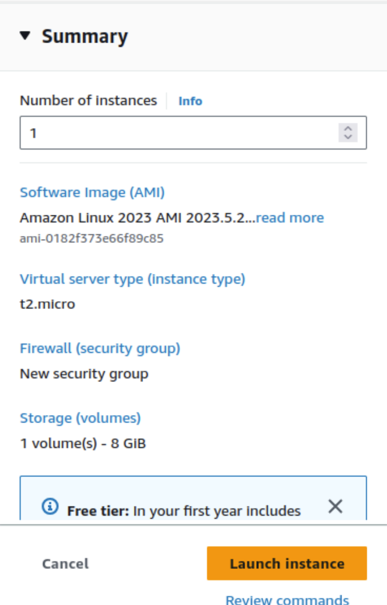



## Then I could finish setting up my database

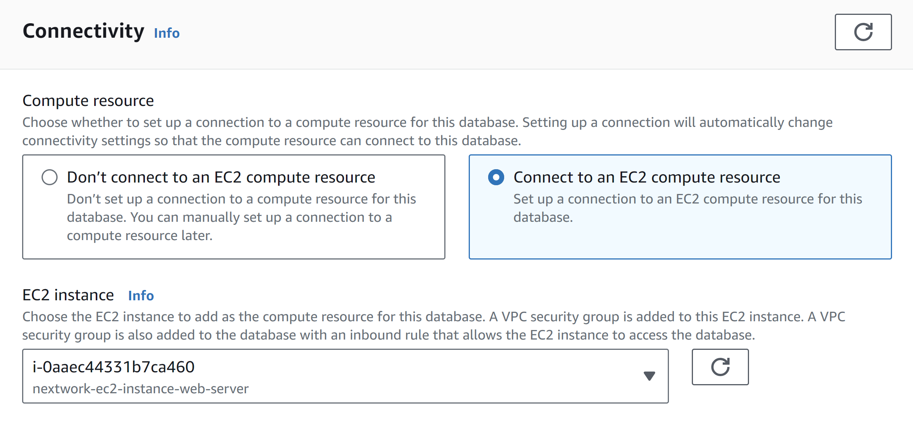

Aurora Database utilizes clusters to ensure high availability. Clusters consist of multiple copies of the same database, so if the primary instance fails, read replicas remain operational, providing backup and maintaining access to the data.

[NextWork.org](https://community.nextwork.org/c/i-have-a-question?automatic_login=true)

# Everyone should be in a job they love.

Check out [nextwork.org](https://community.nextwork.org/c/i-have-a-question?automatic_login=true) for more projects

